**Solver Log Files**

**D.1 Solver Log – 2D Circuit Breaker Simulation**

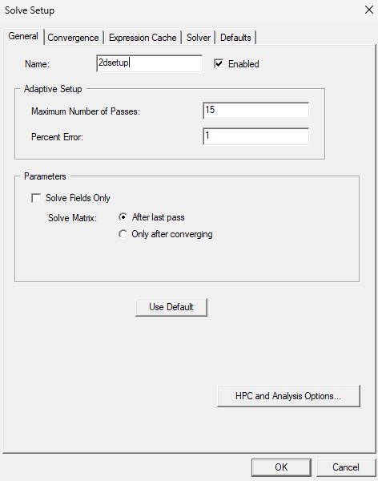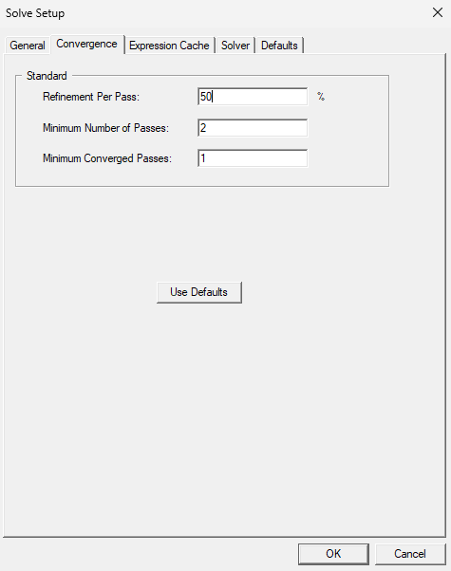

Fig D.1.1 - Solver settings summary (solution type, convergence criteria)

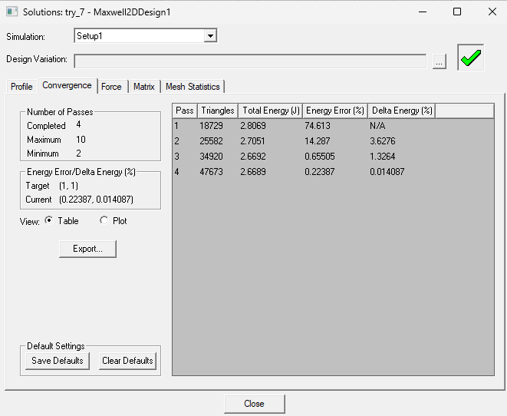

Fig D.1.2 - Iteration log and final error residuals

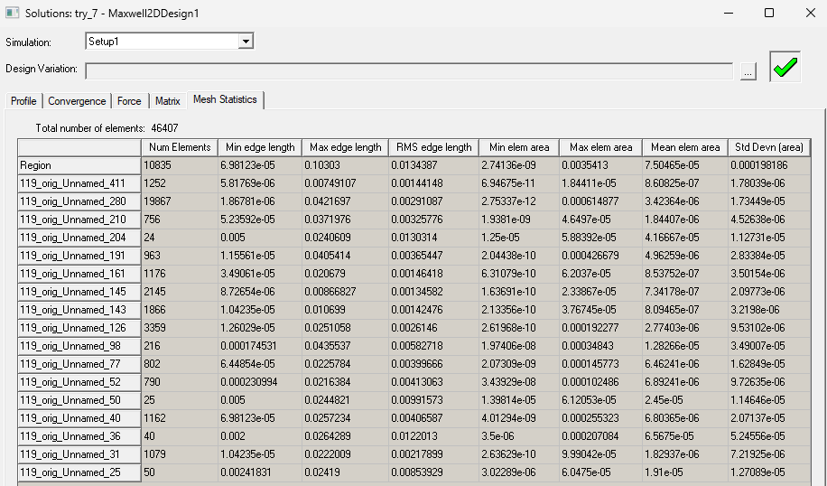

Fig D.1.3 - Mesh adaptation iterations and error thresholds

**D.2 Solver Log – 3D Capacitor Simulation**

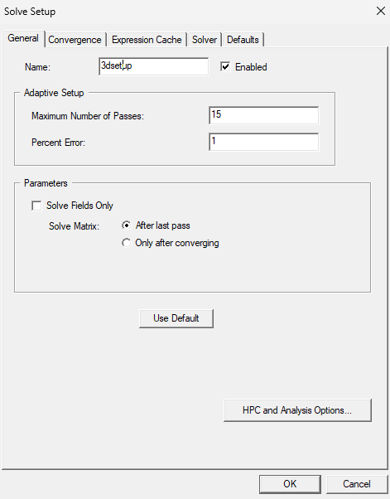

Fig D.2.1 - Solver settings summary (solution type, convergence criteria)

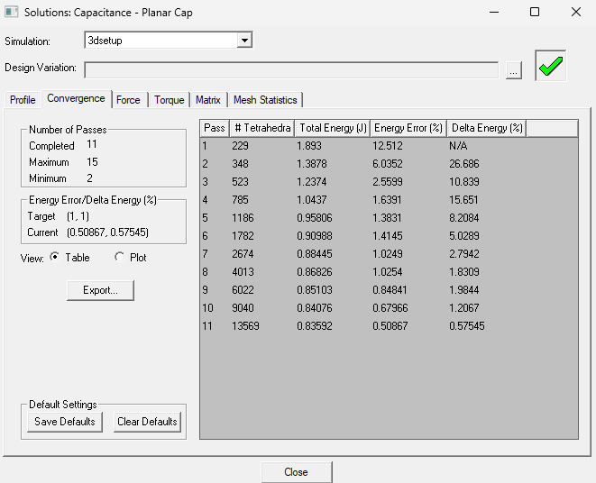

Fig D.2.2 - Iteration log and final error residuals

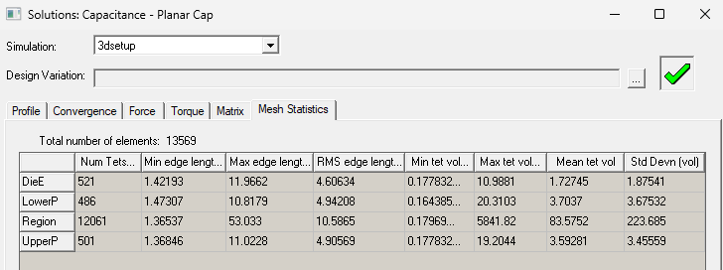

Fig D.2.3 - Mesh adaptation iterations and error thresholds